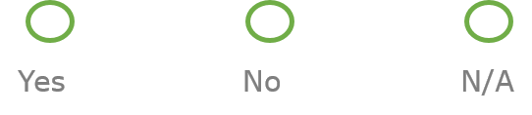
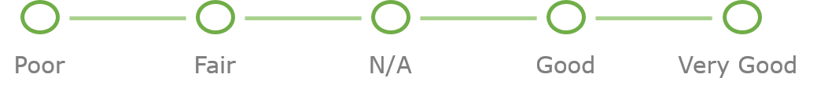

TRACK YOUR LEARNING
Course Survey & CE Request
We encourage you to “Go Green” and use your mobile device! However if you do not have a tablet or smartphone, you can still apply for CE and/or provide feedback! Please complete and return the survey and CE request section for each session attended.
Course Survey:
- The speaker was an effective presenter
- The Program content was relevant:
- Session provided solutions that were relevant to my practice
- Length of session was appropriate
- I would like to receive more information from the speaker
- What did you like most about this session
- What suggestions do you have for improvement

CE Request: (Required for each session taken)
Your Name: |  | Session PIN#
Boards: 1) 2) 3) 4)
Course Name: |  |  | Course Date: ___/___/___
Check Out Time: ____:____ AM/PM | By checking this box, I represent that I attended the course in its entirety to receive continuing education credit(s)

.

