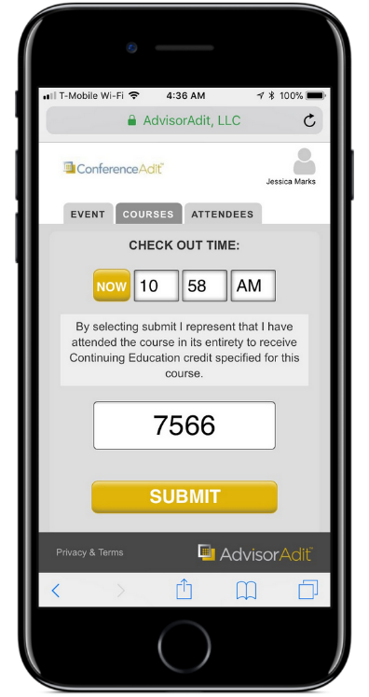
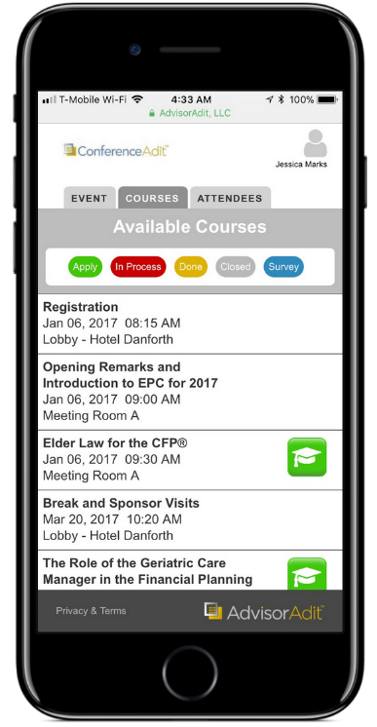






`
Please visit the Registration Desk with any questions
COMPLIMENTARY WIFI:
Network: Password:
- Provide Your Feedback
Complete the brief course survey that follows the CE process. If no CE is available, select the blue Survey icon.
- Check Out
At the course end, note your time and then enter the course PIN provided by your speaker. Note: Some sessions may require that you check in. Your host will let you know.
Mobile Access to Session Resources
Simply click on the link sent to you by your host. No download required! You can:
- Access all session materials
- Register and track your CE
- Take surveys
- Log In
Go to the Courses tab. Use the Email and Zip Code you provided with your registration. Once logged in, you will see the list of available courses.

Three Easy Steps to Register For CE!

Here’s what the icons mean:
CE credit eligible for this course
You need to finish CE registration
Your CE request was received
The course is
closed
Take a quick survey

